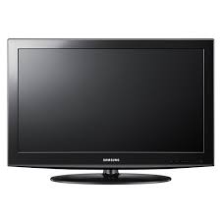

Samsung LCD

* Superb Quality Sound
* Energy Saving Feature
* Screen Size 56 Inch
* Low Maintenance

**Rs.72,500**